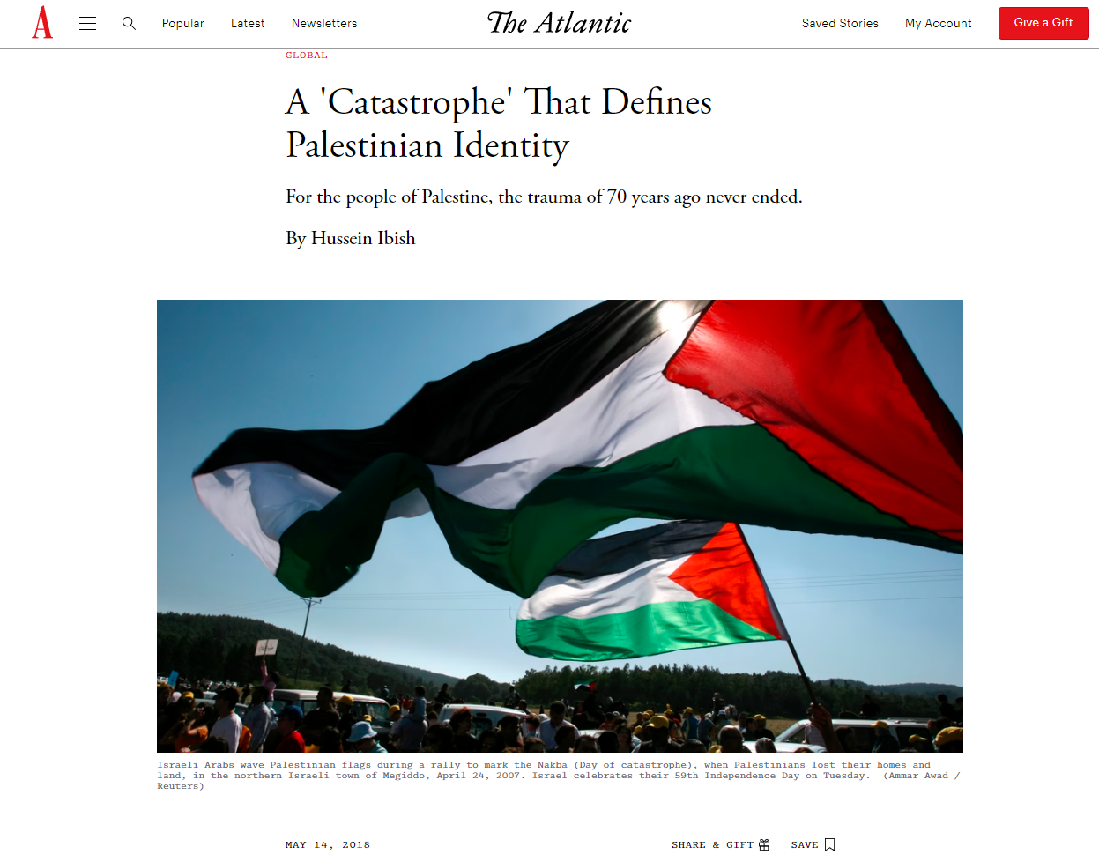

Violence is intensifying in Gaza as the United States opens its new embassy in Jerusalem, a convergence of current politics and long-simmering tensions in the region. Israeli forces opened fire on demonstrators, killing dozens and wounding hundreds more, Palestinian officials said.
May 14 marks the 70th anniversary of Israel’s founding; May 15 is a day Palestinians know as their nakba, or “catastrophe,” the traumatic expulsion of hundreds of thousands of Palestinians from their homes in 1948 by Israelis. This event both defined their future of statelessness and occupation, and now forms the basis for their distinct national identity. Many of the chief consequences of the nakba, including the displacement of most Palestinians from their ancestral lands and ongoing statelessness, remain unresolved to this day.
This helps explain the enduring violence between Israelis and Palestinians, which flared up most recently on the border with Gaza. Beginning on March 30, a series of Friday protests billed the “Great March of Return” have seen thousands of mainly unarmed young men confront Israeli forces and border guards. They are blocking these men from the nearby villages, located in what is now Israel, from which many of their families were displaced in the 1940s. At least 37 protesters have died, and over 4,000 injured, in the unrest. These demonstrations, which will culminate on the 15th, combined with the opening of a U.S. embassy in Jerusalem, may well become yet another historic flashpoint. And even if the worst does not come to pass this time, sooner or later, it will. Until we come to grips with the political and cultural legacy of the nakba, calm, stability, and normality will elude Israel and the rest of the Middle East.
To understand the nakba is to first confront its sheer scale and totality. Before the nakba, there was a large, deeply rooted, and essentially ancient Arab society in most of what, within a few months, became the Jewish state of Israel. In effect, one day it was there, as it had been for living memory, and the next day it was gone. An entire society, with the exception of relatively small groups in a few places, simply vanished.
After World War I, the League of Nations broke the Ottoman Empire up into territories assigned to different colonial powers. The lands that today constitute Israel and the occupied Palestinian territories were placed under British rule, but with two explicit and incompatible purposes: Britain was already committed to supporting the recently established Zionist movement that sought to create “a national home for the Jewish people” in Palestine. The mandate reaffirmed that goal, but did not define what a “national home,” such as a Jewish state, meant in practice.
Yet the terms of the Covenant of the League of Nations held that the purpose of mandates was to secure the “well-being and development” of the people living in those territories. The problem was that just under 90 percent of the population of Palestine in 1922, when the British mandate was formally initiated, were Arab Muslims and Christians, with Jews, in many cases recent arrivals, constituting 11 percent. In other words, the project of providing “tutelage” to the people of the territory and preparing them for independence was at stark odds with the project of transforming Palestine into a “national home for the Jewish people,” however that was defined. In both Britain’s 1917 Balfour Declaration and the Palestine mandate, the overwhelming Palestinian majority was simply referred to as “existing non-Jewish communities,” with “civil and religious rights,” but not political ones.
This meant the British colonial overlords were almost always at odds with both the local Arab population, and also frequently with Jewish leaders. But by the time the British Mandate began to fall apart after World War II, the population of the territory had been transformed: 68 percent were Arabs and 32 percent were Jews (about two-thirds of whom were born abroad). The fledgling United Nations proposed to partition the territory between Arabs and Jews, but even in the proposed Jewish state, gerrymandered to include the maximum number of Jews, there was a virtual Arab plurality. Even after decades of immigration, it still wasn't possible to carve out a significant portion of Palestine with a solid Jewish majority. The Arabs, and especially Palestinians, angrily rejected partition on the grounds that the overwhelming majority of the people of the country did not wish to see their land divided and more than half of it given to the sovereignty of the Jewish minority who, at the time, made up one-third of the population. Many others were expected to arrive at some future date, all against the wishes of the large majority.
Violence between the two communities, and between both and the British authorities, grew common throughout the 1930s and ’40s, including a fully fledged Arab revolt from 1936 to 1939. But as it became clear that Britain was simply going to leave Palestine in 1948, both sides began jockeying for position. Communal violence broke out into open warfare in the fall of 1947. This set the stage for the nakba.
Fighting intensified in January 1948, and the Palestinian exodus began. Up to 100,000 Palestinians, mainly from the upper and middle classes, fled the cities and towns which were the epicenter of the fighting. Until then, expulsions were rare. But in April 1948, the Jewish forces launched a more concerted campaign of massacre and forced displacement, including the notorious Deir Yassin massacre of about 100 Palestinians on April 9. This spread panic among Palestinians, encouraging them to flee.
When terror didn’t do the trick, Palestinians were forced out by Jewish militias. Early April saw the launch of the “Plan Dalet” military campaign, which sought, in part, the ethnic cleansing of most or all of the Arab inhabitants from areas claimed for a Jewish state. As the British withdrew from Palestine in early May 1948, Israel declared its establishment, and the war intensified with the intervention of several Arab armies. The process of Palestinian displacement also intensified. Yitzhak Rabin, then a young Jewish commander, would later write in his memoir of how he was ordered by David Ben-Gurion—literally with the wave of a hand—to “drive out” the 50,000 civilians in the towns of Lydda and Ramla on June 10 and 11.
When the dust settled, the overwhelming majority of Palestinian Arabs, perhaps 700,000 to 800,000 people, had either fled or been expelled. The Palestinians who remained in what was now a Jewish state made up around 18 percent of the population of Israel, and for the next 20 years lived under martial law. The society the Palestinians had composed over the centuries was, for the most part, now gone. Towns and villages were renamed or bulldozed. Property was expropriated en masse through various legal mechanisms. And, most importantly, whether Palestinians fled or were expelled, virtually none were allowed to return. Most Palestinians who left their homes in 1947 and 1948 believed they would one day come back when the fighting stopped, no matter what the outcome. This was a complete delusion. They were gone, and the new Israeli state regarded their absence as the godsend that allowed a Jewish-majority country to suddenly emerge.
This, in brief, is the Palestinian nakba, the collapse and disappearance of an entire society that was politically, militarily, and culturally unprepared for the collision with Zionism, colonialism, and war. But the nakba defined, and continues to define, Palestinian national identity.
At the time of the breakup of the Ottoman Empire, Arab nationalism was running strong. The Muslims and Christians in the territories that were about to become Mandatory Palestine overwhelmingly identified as Arabs, but not yet as an ethno-national Palestinian community. They had warmly welcomed the creation of the first, short-lived, pan-Arab state in 1920, before it was crushed by the French. At that time, many if not most Palestinians saw themselves as Arabs and essentially “southern Syrians.” But once that early Arab state ended, they were, in effect, on their own. They had little choice but to begin defining themselves chiefly as Palestinians.
While Palestinians do have cultural features that distinguish them from other Arabs, it is their history and, above all, the nakba and its never-ending aftermath, that firmly separates them from all other Arabs. All Palestinians, including those left behind in Israel, shared this experience. And given that most Palestinians today are either exiles, refugees, or living under Israeli occupation—or, at best, live as second-class citizens of Israel itself—their collective social, political, and historical identity centers almost entirely around the shattering experience of the nakba. No other group of Arabs endured this.
Historians can and do debate who is at fault for this debacle. But it’s irrefutable that Palestinians didn’t merely lose their putative state and political power. At an individual and familial level, they lost their homes and property, in almost all cases for good. Collectively, they lost their society, and were condemned to live as exiles or stateless subjects under the rule of a foreign military. They had a society, and then they didn’t.
The rupture of the nakba cannot be mended. The state of Israel is a reality that will not disappear. Most Palestinians fetishize the right of return, and from a moral and legal perspective, their case is irrefutable. But politically, there is no chance of any such return, except in tiny, symbolic numbers. After decades of fruitless struggle and brutality on all sides, Palestinians have somewhat bitterly come to accept that the nakba cannot be reversed or even really redressed. They accepted that a two-state solution, with a Palestinian state based in the territories Israel occupied in 1967 living alongside the Jewish state, was the only available outcome. But even that has proven unattainable.
The trauma of the nakba cannot be addressed until the rest of the world, and particularly Israel, recognizes its validity and importance. The event does not compare to the Holocaust—very little else does. But Jews and Palestinians are two peoples both marked by definitive historical traumas that define their worldviews. The difference is that the Jewish and Israeli narratives continue to an epiphany of redemption in the founding and flourishing of the state of Israel, while for Palestinians, permanently dispossessed and living in exile or under occupation, the trauma is enduring and still unfolding.
This is especially true in Gaza, which has become a wretched open-air prison for almost 2 million densely packed residents. The humanitarian crisis and pervasive despair there are so dire that even Israeli security officials regard Gaza as a ticking bomb of human misery. If it does not explode on May 15, it will soon.
Hence the nakba is not so much a historical memory for most Palestinians, as a daily, lived experience. Recognizing that and acting on it will be indispensable for understanding the Palestinian perspective, at long last ending the conflict and the nakba, and allowing Jews and Arabs, and the whole world, to finally move on.
Hussein Ibish is a senior resident scholar at the Arab Gulf States Institute in Washington.

